**Quadrant II – Transcript and Related Materials**

**Programme:** Bachelor of Science (Third Year)

**Subject :** Physics

**Paper Code:** PYC 105

**Paper Title :** DSC: Classical Mechanics & Thermal Physics – Section II

**Unit :** Statistical distributions

**Module Name:** Experimental verification of Maxwell Boltzmann distribution

law ( Zartman Ko experiment )

Bose Einstein and Fermi Dirac statistics ( qualitative study )

**Module No:** 19

**Name of the Presenter:** Mahendra R. Pednekar

T

**Notes :**

**Experimental verification of Maxwell Boltzmann distribution law ( Zartman ko experiment)**

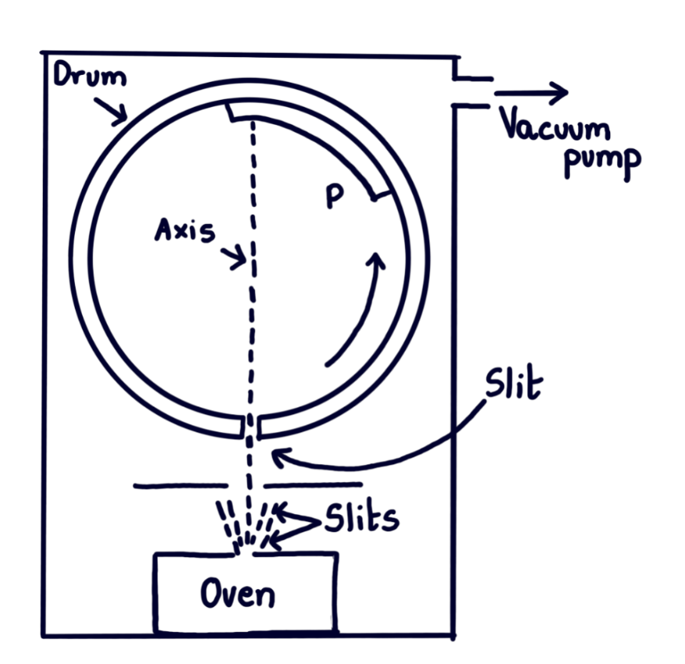

A direct experimental verification of the Maxwell-Boltzmann law of distribution of molecular speeds was made by Zartman and Ko in 1930. The figure shown describes the experimental arrangement used by them. They used an oven containing bismuth vapour at a known high temperature of about 8270C. Molecules of Bismuth emerge from a slit in the oven into an evacuated region above. Fast moving molecules escape from the oven more often than the slow ones. The beam is made unidirectional by a second slit, collimating it. Above this slit, there is a cylindrical drum which can be rotated in the vacuum about a horizontal axis perpendicular to the plane of the figure. There is a small opening to the drum to enable the beam of molecules to enter it. Initially the drum is held stationary so that the beam can enter the drum. The beam moves along a diameter of the drum and the molecules are deposited on a glass plate P, mounted on the inside wall of the drum just opposite the opening of the drum. During the experiment, the drum is constantly rotated at a constant angular speed, so that bursts of molecules enter the drum in each rotation. Since the speeds of the molecules differ, some molecules cross the diameter quickly and others take a longer time. Also the drum turns while the molecules move across it, hence they strike the glass plate at different places. Thus using this apparatus, the distribution of molecular speeds is translated into a distribution in space around the inside of the drum. This is indicated by the variation in the variation in the darkening of the glass where the bismuth is deposited . The thickness of the deposit of the deposit is measured optically and comparison is made of the observed distribution of molecular speeds with the Maxwell-Boltzmann theoretical distribution. The two are in excellent agreement.

**Bose Einstein Statistics**

Identical and indistinguishable particles which have spin zero or integral spin are called classified as Bose particles or Bosons. They do not obey the Pauli exclusion principle.

Consider a system of identical particles, each having a total spin angular momentum which is integral, i.e. 0,1,2,3,…….. . example of such system are collection of He4 atoms or photons. We know that the wave function Ѱ of the system must be symmetric i.e. it should remain unchanged under interchange of any two particles. Thus interchange of any two particles does not lead to a new state for the system. The particles must, therefore, be considered indistinguishable, in considering different states of the system. There is no restriction on how many particles can there be in any one single particle state. Particles which satisfy the symmetry requirements stated above obey the Bose-Einstein statistics and are called bosons.

Imagine a box divided by gi - 1 partitions into gi sections. The ni particles are to be distributed among these sections. The total number of permutations of the ni particles and the gi – 1 partitions is ( ni + gi – 1 )!. Since the ni particles are indistinguishable, permutations among the particles do not really produce a new arrangement. Hence the total number of permutations of ni particles and gi – 1 partitions is . Further, the permutations among the gi – 1 partitions do not alter the fact that there are still gi sections, hence division of the total number of permutations by ( gi – 1) is also necessary. Thus the number of ways in which ni particles, which are indistinguishable, can be distributed in gi sections is .

**The Fermi Dirac Statistics**

The Fermi Dirac statistics is applicable to particles having a total spin angular momentum which is half integral i.e. , , ……. Here wave function Ѱ of the system is antisymmetric to an exchange of any pair of particles. Such particles which include protons, neutrons, electrons etc. obey Pauli exclusion principle when they are in the same system. i.e when they move in a common force field, each member of the system must be in a different quantum state. But interchange of two particles does not lead to a new state of the system, thus particles are identical and indistinguishable. Thus identical particles satisfying the antisymmetry requirement of wave function, with half integral spin and indistinguishable, obey the Fermi-Dirac statistics and are called fermions.

Assume that the total number of particles N is a constant and so also is the total energy ET. Since the particles are identical and indistinguishable, and obey the Pauli exclusion principle, each cell can be occupied at the most by one particle.

Suppose that there are gi cells or quantum states corresponding the same energy Ei and ni particles, then ni cells will be occupied wheras gi – ni cells will be vacant. gi ≥ ni . The gi cells can be arranged in gi! Ways. Since the particles are indistinguishable, the permutations ni! Of the particles among themselves are irrelevant and so is ( gi – ni )!, which is the permutations of the vacant cells among themselves, as the cells are not occupied. Thus the total number of distinguishable ways in which identical particles occupy gi states is