**Quadrant II – Notes**

**Programme:** T. Y. B. Sc. (Hons.) Agri.

**Subject:**  Agricultural Economics

**Course Code:** ELE ECON 354

**Course Title:**  Agribusiness Management

**Module Name:**  Methods of Project Appraisal

**Module No:** 14

**Name of the Presenter:**  Dr. Rachana Kolambkar

**Notes:**

**Methods of Project Appraisal**

* Undiscounted Measures
* Discounted Measures

**Undiscounted Measures**

**Payback Period:** Payback period in capital budgeting refers to the time required to recover the funds expended in an investment, or to reach the break-even point.

**Proceeds per Rupee of Outlay:** This is measured by dividing the total proceeds by the total investment. The project measures highest magnitude of the parameter.

This method is another method of choosing between the projects and measured by the following formula:

Average annual proceeds of rupee = ( Total proceeds / Life span of project ) / Total Investment

The projects are estimated by the magnitude of the estimate.

The major draw back of the undiscounted measures is that for the same data of the project, we will get **different rankings** depending upon the measure. Thus undiscounted measures are **inconsistent** and **incompatible** in ranking.

**Methods of Project Appraisal**

* Discounted Measures
* Net Present worth (NPW)
* Benefit Cost Ratio (B:C Ratio)
* Internal rate of Return (IRR)
* Profitability Index
* Sensitivity Analysis

**Methods of Project Appraisal**

1. The Net Present Value (NPV) is a method that is primarily used for financial analysis in determining the feasibility of investment in a project or a business. It is the present value of future cash flows compared with the initial investments.

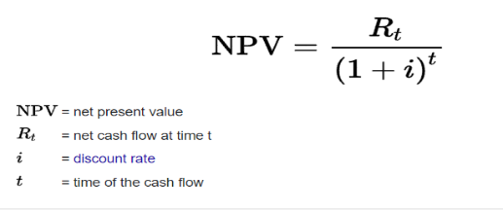

**2. A benefit-cost ratio (BCR)** is a ratio used in a cost-benefit analysis to summarize the overall relationship between the relative costs and benefits of a proposed project.

BCR can be expressed in monetary or qualitative terms. If a project has a BCR greater than 1.0, the project is expected to deliver a positive net present value to a firm and its investors.

3. **The Internal Rate of Return (IRR)** is the discount rate that makes the net present value (NPV) of a project zero. In other words, it is the expected compound annual rate of return that will be earned on a project or investment.

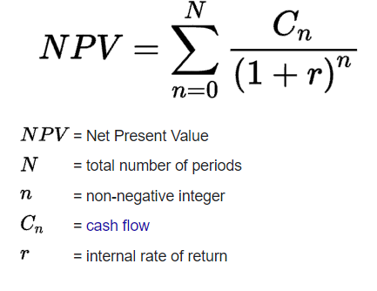

**4.The profitability index (PI)** is a measure of a project's or investment's attractiveness. The PI is calculated by dividing the present value of future expected cash flows by the initial investment amount in the project.

**5. Sensitivity analysis** is a financial model that determines how target variables are affected based on changes in other variables known as input variables. This model is also referred to as what-if or simulation analysis. It is a way to predict the outcome of a decision given a certain range of variables.